What Is Work-Based Learning?
Work-based learning (WBL) in New Mexico connects students with real-world work experiences that help them build the skills and knowledge needed for future careers. These experiences take place in a workplace or a realistic, industry-based setting and are designed in partnership with employers like you.
WBL is structured to ensure that students gain meaningful, relevant skills aligned to both classroom learning and industry needs. Each experience includes clear learning goals, guided supervision, and opportunities for students to apply what they are learning in real time. Participation in WBL can also support students’ progress toward graduation by contributing to academic credit and program of study requirements while helping students take the next step toward college or a career.
WBL experiences can vary in format, length, and setting, ranging from short-term experiences to more immersive, hands-on roles. All experiences are designed to ensure that students gain meaningful, career-relevant skills in a safe and well-supported environment. Opportunities may be offered in person or virtually through partnerships with employers, community organizations, and educational institutions.
The purpose of WBL is to build students’ awareness of potential careers, support their exploration of career opportunities, and prepare them for future employment in New Mexico. These experiences help students make informed decisions about high school coursework, postsecondary education, and career pathways. The New Mexico WBL continuum is organized into four stages—Learning Of, About, For, and Through Work—to illustrate how WBL experiences deepen over time.
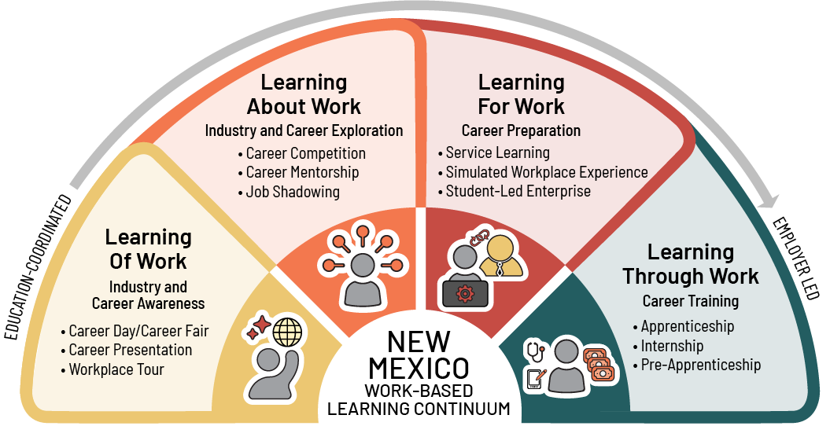

Benefits for Employers
WBL can be part of your broader talent recruitment strategy. When WBL experiences are designed through intentional partnerships among schools, employers, the community, and workforce organizations, they offer many benefits:
- Build a Custom Talent Pipeline: Stop searching for the “perfect” candidate and start building them. WBL allows you to train students in the specific technical skills and company culture your business requires. Gain access to future candidates for part-time, summer, and eventual full-time jobs.
- Reduce Recruitment and Onboarding Costs: Use internships and pre-apprenticeships as “long-term interviews.” Employers report that WBL strengthens retention and accelerates skill development, enabling participants to become productive team members more quickly than traditional hires.
- Spark Innovation: Benefit from young adults who bring a tech-savvy mindset and fresh ideas that can help accelerate progress and modernize approaches.
- Strengthen Community Presence: Position your company as a leader in New Mexico’s economic growth. Supporting local students and schools builds brand loyalty and creates a positive public image for your business.
- Grow Your Own Local Workforce: Influence talent attraction and retention by demonstrating viable employment opportunities that encourage young adults to stay in their local communities to meet workforce needs.
WBL also provides indirect benefits that help improve the performance of your existing workforce:
- Cultivate Emerging Leaders: Mentoring a student provides your mid-level employees with a practical, low-stakes environment to refine their management, communication, and coaching skills.
- Renew Employees’ Sense of Purpose and Engagement: Connecting with students reminds employees of why they chose their career path, reigniting their own passion for the industry through the eyes of a newcomer.

Benefits for Students
Students benefit from employer engagement in WBL by deepening their learning, applying academic and technical knowledge in real-world settings, and gaining opportunities to:
- Clarify Career Goals: Students explore career pathways firsthand to make informed decisions about future education and employment.
- Master In-Demand Skills: Students develop the professional and technical competencies required by modern New Mexico industries.
- Expand Professional Networks: Students gain access to mentors and job opportunities that lead to higher paying roles and smoother transitions into the workforce.

YOUR Role as the Employer
Employers play a critical role in connecting students to their future careers. Through WBL, you help students build both technical and professional skills while reinforcing workplace safety. Employers can engage in a variety of ways, such as serving as guest speakers, hosting workplace tours, mentoring students, and providing hands-on learning experiences. These interactions offer valuable guidance, set high expectations, and help students develop industry-relevant skills. The following are examples of WBL experiences and the typical time commitments associated with each:
Employer Partner Engagement and Responsibility Matrix
The following matrix outlines a range of WBL experiences across different levels of time, responsibility, and partnership commitment.
 | Supporting  (Hours) | Partnering  (Days) | Leading  (Weeks) | Championing  (Months)
Learning Of Work  (Industry and Career Awareness) | Workplace Tour (1.5-2 hours) | Career Presentation  (2-4 hours) | Guest Speaker Series  (15 hours per semester) | Themed Project  (24+ hours)
Learning About Work (Industry and Career Exploration) | Informational Interview  (30-90 minutes) | Job Shadowing  (4-8 hours) | Career Competition  (2-15 hours) | Career Mentorship  (45+ hours)
Learning For Work  (Career Preparation) | Resume Development / Mock Interview  (1-2 hours) | Simulated Workplace Experience  (8-15 hours) | Student-Led Enterprise  (15 hours) | Service Learning  (2-90 hours)
Learning Through Work  (Career Training) | Clinical Experience  (4+ hours) | Teacher Externship  (15-60 hours) | Internship  (60+ hours,  6-8 weeks) | Pre-  Apprenticeship  (400 hours)

How YOU Can Engage With WBL in YOUR Community
To learn more about partnering to provide career awareness, exploration, preparation, or entry experiences for students in your community, please contact: <Insert Name, Title, name@email.com, (xxx) xxx-1234>.

